**Exercise 11: Getting familiar with mongosh**

**Name: Đoàn Nam Sơn De180896**

# Objective

The MongoDB Shell, is a great way to interact directly with your MongoDB databases and perform a variety of tasks. In this exercise, you'll learn how to query and update data to managing your database configurations.

# Exercises

## Exercise 1: Do all requirements basing on the articles in db.json file

* Create database namely Newspaper

* Create a collection named articles and insert a new article

* Insert many articles in articles collection

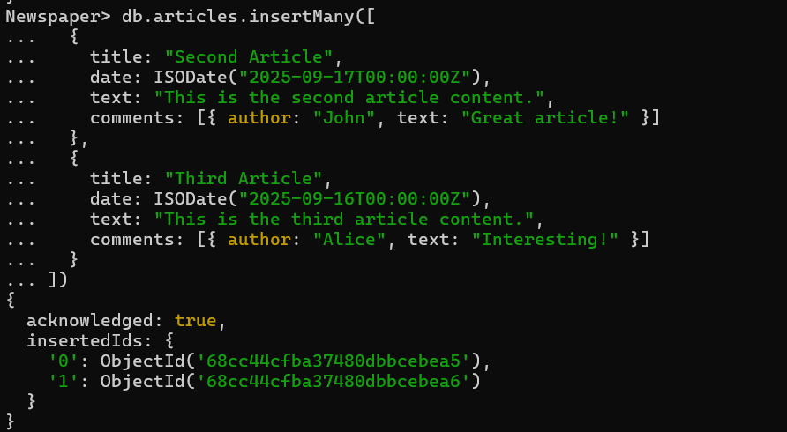

* Retrieve the document you just inserted

* Add another comment in available articles

Check:  
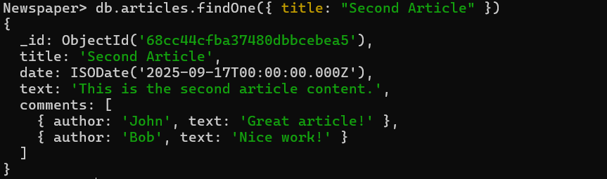

* Delete a specific comment made by "Alex" from an article

## Exercise 2: Do all requirements basing on the videos in db.json file

* Create a collection named video and insert a new video

* Insert many videos in videos collection

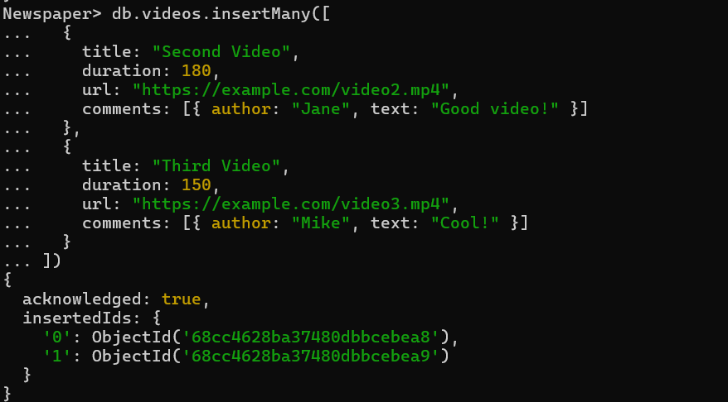

* Find the video by its title:

* Add another comment in available video

Check:

# Conclusion

This exercise aims to practice these basic commands and exploring more complex operations. You'll become more comfortable with managing and querying your MongoDB databases using mongosh.